**Cisco**

As a **Cisco training provider in Malaysia**, we can help you to join the ranks of IT professionals who have helped make us the world's largest and most trusted Cisco Learning Solutions Partner. For our Cisco training, we enhance Authorized Cisco curriculum with custom, hands-on exercises and labs delivered by professionals with real-world networking experience and a results-oriented approach to instruction.

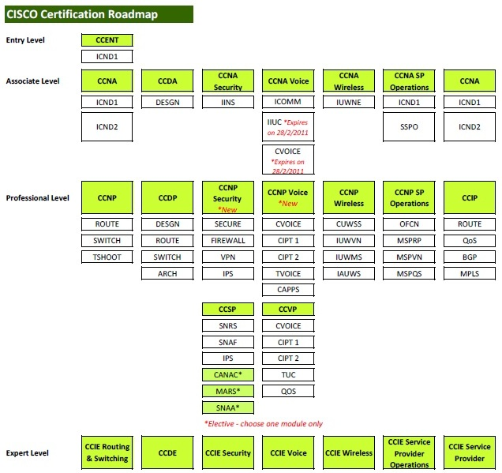

|  |
| --- |
| [CCENT - Cisco Certified Entry Network Technician](http://www.globalknowledge.com.my/index.php?option=com_virtuemart&page=shop.browse&category_id=32&Itemid=159) |
| [CCNA - Cisco Certified Network Associate](http://www.globalknowledge.com.my/index.php?option=com_virtuemart&page=shop.browse&category_id=15&Itemid=159) |
| [CCDA - Cisco Certified Design Associate](http://www.globalknowledge.com.my/index.php?option=com_virtuemart&page=shop.browse&category_id=21&Itemid=159) |
| [CCNA Wireless](http://www.globalknowledge.com.my/index.php?option=com_virtuemart&page=shop.browse&category_id=16&Itemid=159) |
| [CCNA Voice](http://www.globalknowledge.com.my/index.php?option=com_virtuemart&page=shop.browse&category_id=17&Itemid=159) |
| [CCNA Security](http://www.globalknowledge.com.my/index.php?option=com_virtuemart&page=shop.browse&category_id=22&Itemid=159) |
| [CCDP - Cisco Certified Design Professional](http://www.globalknowledge.com.my/index.php?option=com_virtuemart&page=shop.browse&category_id=24&Itemid=159) |
| [CCNP - Cisco Certified Network Professional](http://www.globalknowledge.com.my/index.php?option=com_virtuemart&page=shop.browse&category_id=23&Itemid=94) |
| [CCIP - Cisco Certified Internetwork Professional](http://www.globalknowledge.com.my/index.php?option=com_virtuemart&page=shop.browse&category_id=26&Itemid=159) |
| [CCNP Wireless](http://www.globalknowledge.com.my/index.php?option=com_virtuemart&page=shop.browse&category_id=35&Itemid=159) |
| [CCNP Security](http://www.globalknowledge.com.my/index.php?option=com_virtuemart&page=shop.browse&category_id=76&Itemid=159) |
| [CCNP Voice](http://www.globalknowledge.com.my/index.php?option=com_virtuemart&page=shop.browse&category_id=77&Itemid=159) |
| [CCIE Routing and Switching](http://www.globalknowledge.com.my/index.php?option=com_virtuemart&page=shop.browse&category_id=33&Itemid=97) |
| [CCIE Security](http://www.globalknowledge.com.my/index.php?option=com_virtuemart&page=shop.browse&category_id=75&Itemid=159) |
| [CCDE - Cisco Certified Design Expert](http://www.globalknowledge.com.my/index.php?option=com_virtuemart&page=shop.browse&category_id=34&Itemid=159) |
| [Additional Cisco Courses](http://www.globalknowledge.com.my/index.php?option=com_virtuemart&page=shop.browse&category_id=29&Itemid=159) |
| [Routing & Switching Training](http://www.globalknowledge.com.my/index.php?option=com_virtuemart&page=shop.browse&category_id=36&Itemid=159) |
| [Cisco R&S Protocol Training](http://www.globalknowledge.com.my/index.php?option=com_virtuemart&page=shop.browse&category_id=37&Itemid=159) |
| [Cisco Unified Messaging Training](http://www.globalknowledge.com.my/index.php?option=com_virtuemart&page=shop.browse&category_id=38&Itemid=159) |
| [Cisco Unified Wireless](http://www.globalknowledge.com.my/index.php?option=com_virtuemart&page=shop.browse&category_id=74&Itemid=159) |
| [Cisco Unified Communications Manager 7.0 Training](http://www.globalknowledge.com.my/index.php?option=com_virtuemart&page=shop.browse&category_id=39&Itemid=159) |
| [Additional Cisco Unified Communications Training](http://www.globalknowledge.com.my/index.php?option=com_virtuemart&page=shop.browse&category_id=40&Itemid=159) |
| [Foundations Specialization Training](http://www.globalknowledge.com.my/index.php?option=com_virtuemart&page=shop.browse&category_id=41&Itemid=159) |